9/17/2026
LAB NO 02
Operating System
Instructor: Ms. Muneeba Banaras
Submitted By: Wasif Ali
Reg ID: 245187
Class: BSCS F’24 B

LAB TASK

Windows Tasks
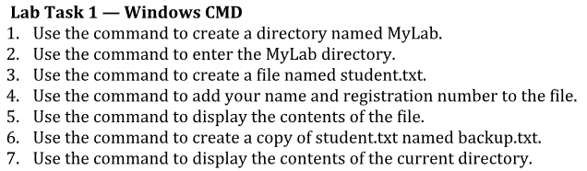
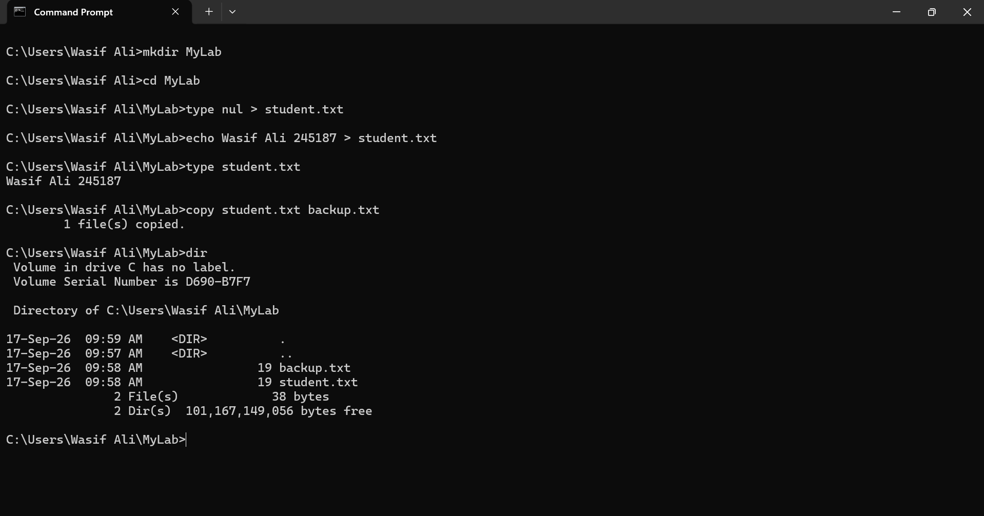

Ubuntu Tasks

